POST-OP INSTRUCTIONS FOLLOWING
DIRECT TO IMPLANT
BREAST RECONSTRUCTION

FOLLOW-UP APPOINTMENTS /
IMPORTANT TELEPHONE NUMBERS

- Your follow-up appointments will be given to you before you leave the hospital. You will see the Plastics Nurse 4- 5 days and your Plastic Surgeon in two weeks. If it is not provided to you at the time of discharge, you may call the following numbers to make an appointment:
- For patients of Dr. Buchel – please call Tora at (204) 787 – 7224
- For patients of Dr. Hayakawa – please call Mandy at (204) 787 – 7158

The follow-up clinic for your doctor and nurse is located at: 800 Sherbrook Street in the Rehabilitation Hospital on the 4th floor (take the Magenta Fox elevators up to the 4th floor).

- The nurse office hours are Monday to Friday, 8:00am to 4:00pm. If you have any questions or concerns after your surgery, and would like to speak to the Plastics Nurse Clinician, you may call them at the following numbers:
  - Heather (Dr. Buchel’s Nurse) – please call (204) 787 – 8830
  - Laura (Dr. Hayakawa’s Nurse) – please call (204) 787 -- 8829

For urgent concerns after hours, please call hospital paging at (204)787 – 2071 and ask to speak to the Plastic Surgery Resident on call OR come to the HSC Emergency Department.

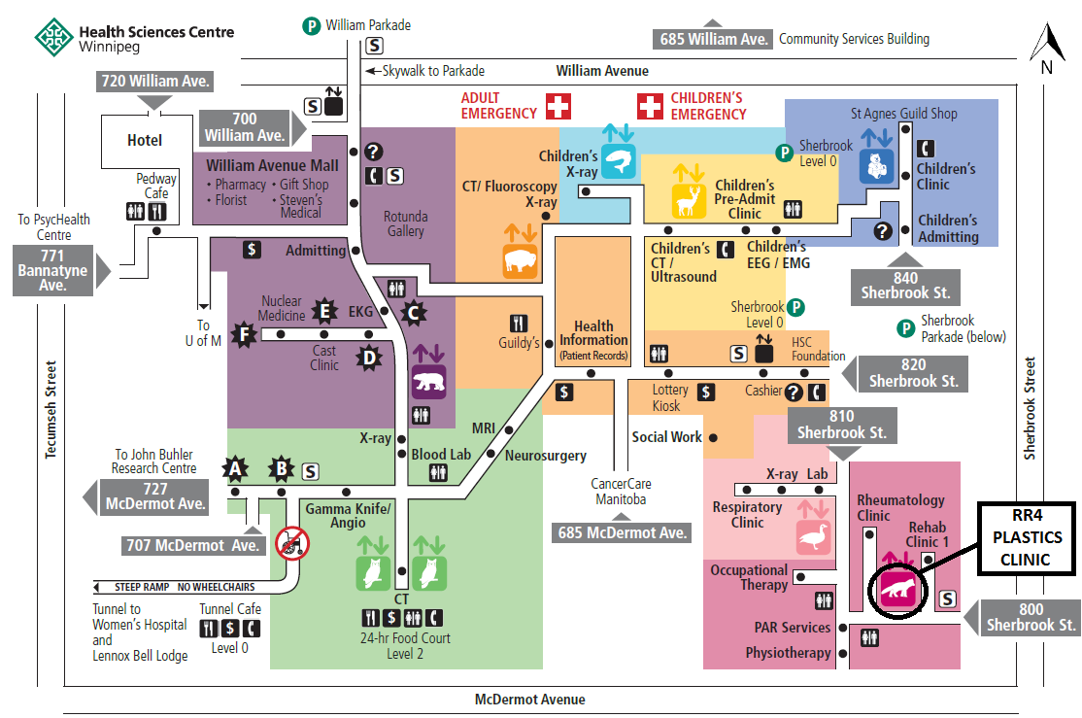

SUTURES

- Dependent on the surgeon and preference for your reconstruction, you may have dissolvable or non-dissolvable stitches.
- Drain tubes are held in place with a suture. The suture is removed once the drain is ready to be taken out.

DRESSINGS

- You will have a bulky dressing across your chest.
  - This bulky dressing will be removed at your follow-up visit with the nurse.
  - Please keep this dressing dry until your appointment with the nurse.

BLOOD CLOTS

- It is important to do short periods of light activity/walking 5-6 times per day to help prevent blood clots in the legs or lungs.
- Types of blood clots:

  - Deep Vein Thrombosis (DVT):
    - Is a blood clot that is in the vein deep in your arm or leg. Deep vein clots can break off and travel to your lungs, causing a Pulmonary Embolism (PE).

    - Signs & Symptoms:
      - Swelling in the arm or leg.
      - Pain and/or tenderness in the affected limb.
      - Increased warmth in the limb that’s swollen or painful.
      - Discoloration or redness of the skin on the affected limb.

  - Pulmonary Embolism (PE):
    - A pulmonary embolism is when a blood clot travels from a deep vein in the body to the lungs. It is a serious condition that can cause damage to your organs, lungs, and decrease the levels of oxygen in your blood.

    - Signs & Symptoms:
      - Unexplained shortness of breath.
      - Chest pain, it may feel like you’re having a heart attack, the pain may worsen with deep breathes, and won’t go away when you are resting.
      - Coughing up blood.
      - Rapid heart rate, feels like your heart is racing.
      - Light-headedness or dizziness.
      - Excessive sweating.
      - Clammy or discoloured skin.

Please seek medical attention immediately if you notice or experience any of the signs & symptoms as mentioned above.

DIET / SMOKING

- Eating a healthy diet is important in promoting wound healing, maintaining a strong immune system, and keeping your body healthy while you are healing.
- Eat meats, fruits, and vegetables will help promote wound healing.
- Constipation may be an issue after surgery related to the pain medication, decreased mobility, and the abdominal incision. Please drink plenty of fluids to keep yourself hydrated, eat a diet high in fiber, and take a stool softener/laxative until your bowel regime is back to normal.
- Smoking may increase your risk of complications after surgery.
  - Please avoid smoking and any sources of second hand smoke for at least 6 weeks.

SIGNS & SYMPTOMS OF INFECTION

- Please seek medical attention if you notice any of the following:

  - Increased warmth or spreading redness to site
  - Increased swelling, pain, and tenderness
  - Bad odour
  - Increased discharge at site (creamy yellow/green)
  - Fever/chills

WHAT TO EXPECT AFTER SURGERY

- The first 24 - 48 hours after surgery is usually the time you will feel most discomfort and will progressively feel better each day.
- Please take medications regularly as directed to alleviate the pain.
- Swelling reaches its peak at 48 – 72 hours post-surgery and takes about 3 months for it to subside.
- There may be some bruising as well and may take approximately 2 – 3 weeks for it to fade.
- Please expect to have a 4 to 6 week recovery period following direct to implant breast reconstruction. Returning to regular activity will depend on how you heal and is different for everyone.
- If possible, we also suggest that you have someone with you at home for the first week after surgery to help with activities of daily living and meals. If you have any young children at home, please arrange for someone to help with childcare for a few weeks.
- It is not uncommon to feel intermittent spasms of the pectoralis muscle or have shooting/zapping pains in your breast. This is usually a sign the nerves and muscles are regenerating and repairing themselves.
- Your incision may appear puckered and pleated along the suture line. This will require time for the puckers and pleats to flatten out. Sometimes massaging the incision will help them settle. If these do not flatten out, your surgeon may be able to revise them.

ACTIVITIES / RESTRICTIONS POST-SURGERY

- You may climb stairs.
- It is important to do short periods of light activity/walking 5 – 6x per day to prevent blood clots.
- You may drive as long as you are not on narcotics and feel safe to drive.
- Please see chart below for further activities and restrictions.

Day after surgery to end of week 2 …
  - Take it easy for the first few weeks.
  - No exertional activity/sports.
  - Take short walks several times a day to prevent blood clots from forming.
  - Do not lift anything heavier than 5 pounds / 2 kilograms (example: a phone book)
  - Keep the initial dressing on from surgery and sponge bathe until your first follow-up with the nurse.
  - Keep your elbow below your shoulder. It is ok to move your arms around to brush your hair or to reach for something, as long as your elbows are below your shoulders.
  - Sleep on your back with pillows propped up behind you (this position is usually more comfortable on your chest, and help your implants stay in good position while they heal).
  - Take pain killers and antibiotics as they are prescribed.
  - You may switch to an extra strength Tylenol when you feel better.
  - It is ok if you run out of antibiotics. We do not put you on antibiotics for long term unless there are any signs and symptoms of infection. If you notice any signs of infection, please seek medical attention.
  - Do not remove steri-strips over your incision.

End of week 2 …
  - You may start to sleep on your side, or when you feel comfortable to do so.
  - Continue to wear your bra 24/7
  - Do not lift more than 10 pounds / 5 kilograms (example: a small baby)
  - No restrictions on shoulder movement. Your elbows may be above your shoulder.
  - Keep the steri-strips on your incision.

End of week 3 …
  - Sutures may be removed by the clinic nurse once your incisions are fully healed.
  - You may sleep without a bra (once your surgeon says it is ok). Please wear one when you are up and walking for 6 weeks.
- No exertional activity/sports, brisk walking is ok, no upper strength body training.
  - Continue to wear your surgical bra.
  - Do not lift more than 10 pounds / 5 kilograms (example: a small baby).
  - Your doctor may suggest you to do breast massage (Please read below if your doctor indicates breast massage will be beneficial). Only start breast massage if your surgeon/nurse indicates it is ok to do so.
    - It is important to massage your implants daily to prevent capsular contracture for as long as your implants are in you.
    - Capsular contracture is where scar tissue forms around breast implant causing it to be tight, hard, and painful. When this happens, please notify your surgeon, as you may need surgery to release the scar tissue around the capsule.
    - Start gently; week by week gradually increase the amount of pressure you are using.
    - We will show you in clinic.

End of week 6…
  - No restrictions on activity and exercise start slowly and listen to your body. If you find an activity or exercise is painful or sore… stop, and gradually return to it when you feel comfortable.
  - You may now wear a wired bra.
  - You may go without a bra when you are up and about.
  - Please wear a supportive sports bra when you are exercising.
  - If you are still finding limitations in your movement, please contact us and we will set up physiotherapy.
  - You may resume sexual activity.

OTHER:
  - You may need further surgery for revisions (ex/ scar revisions, fat injections etc…). This will be discussed at your follow-up appointments with the surgeon.
  - If no revisions are needed you may get a 3-dimensional nipple/areolar tattoo in 3 months. Please book with either Jessica (Dr. Buchel) or Mandy (Dr. Hayakawa).

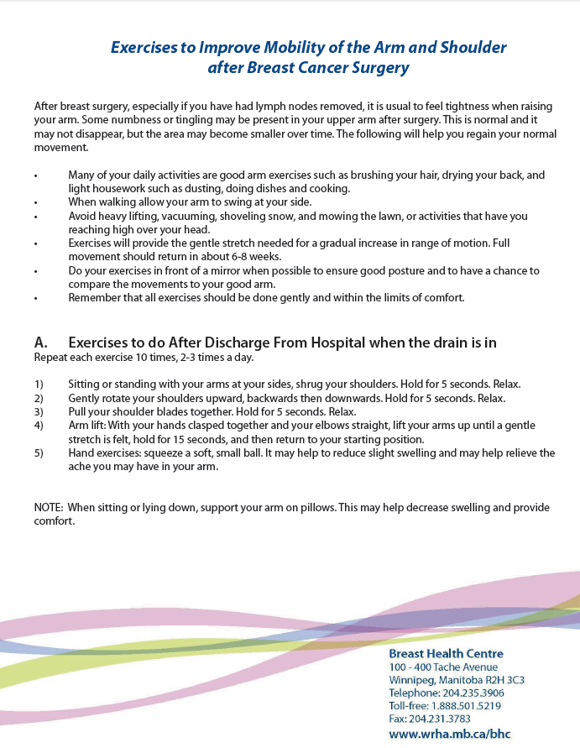
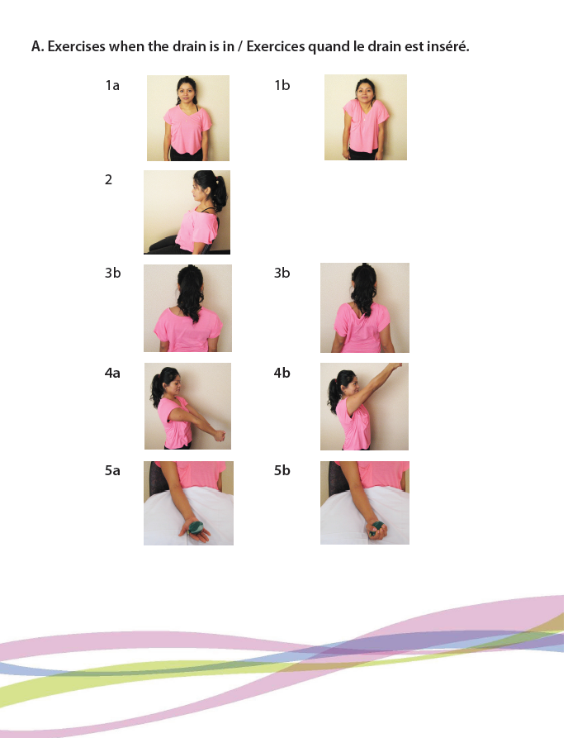
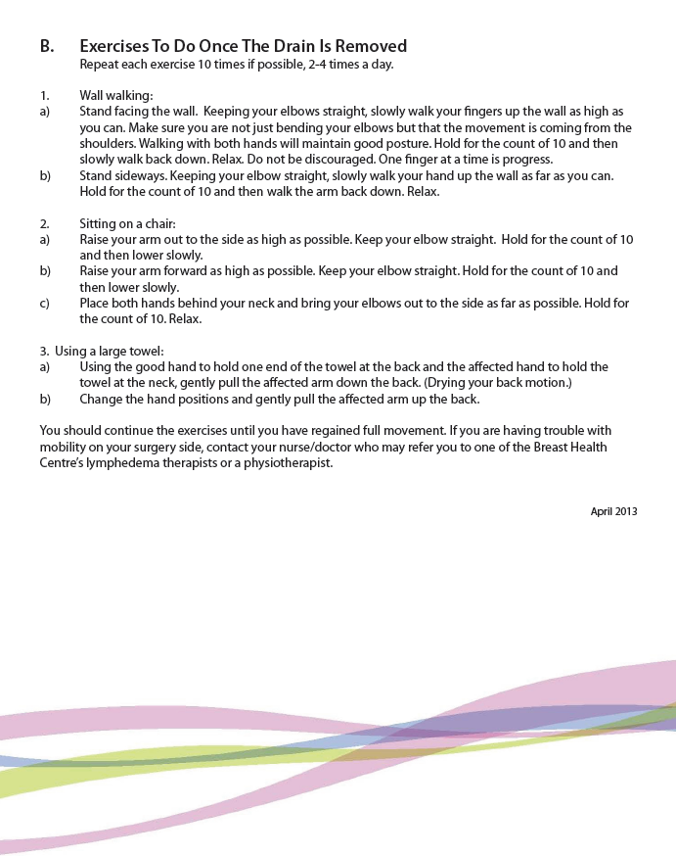
Do not start these excercises until 2 weeks post-op
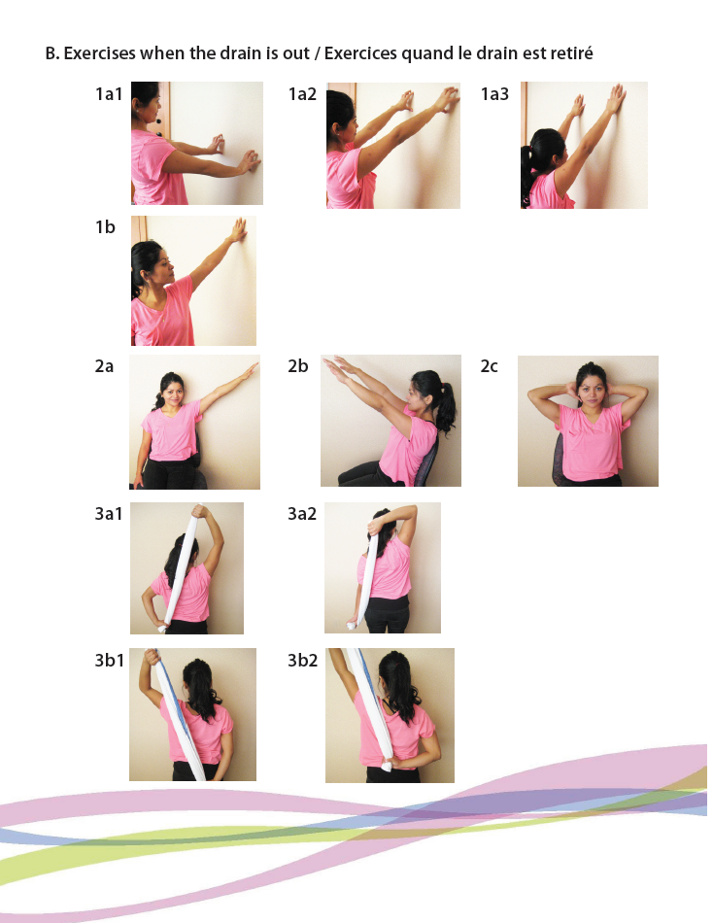
DRAIN CARE

- You may be discharged home with drains to the breast.
- The drains should be emptied twice a day or as needed and recorded (example/ at 9:00am and 9:00pm).
- Each drain must be checked separately and amounts recorded and added up separately.
- Please bring the drain record to your first follow-up appointment. This will determine whether the drains can come out.

EXAMPLE | Right breast drain | Right abdominal drain
9:00am | 40ml | 60ml
9:00 pm | 25ml | 30ml
DAILY TOTAL | 65ml | 90ml

- Before you empty the container the tubing should be “milked” to prevent clots from plugging the tube. Do this by using one hand to hold the tubing closest to your skin in a stable position. With the other hand gently pinch the tubing and slide your fingers down toward the drain canister.

- Wash your hands.

- Open the lid of the drain and empty contents into a measuring cup.

- Squeeze all the air out of the drain canister and then replace cap.

- Check the measuring cup and record the drainage.

- Check the color and the odour of the drainage and notify the clinic nurse if the drainage has a foul smell and/or change of color (frank red blood).

- Flush the drainage down the toilet and was your hands.

- Drainage tubes are ready to be removed when the amount coming out of the drain is less than 30ml in a 24 hour period. Please call the office assistants to arrange a time to come to the clinic to have the drains removed.

NOTE: If a drain tube is accidentally pulled out from the site, NEVER try to push the tube back into your body. If the drain canister is still holding suction please tape the tube where it is. If not you may let the rest of the tube gently slide out (do not pull if it feels stuck) and apply a clean gauze bandage to the site. Please call the hospital if any of these problems arise for further instructions.

For further information please visit our website at www.breastreconstructionprogram.com

Revised September 2016


DRAINAGE RECORD
LAST NAME: ___________________________ FIRST NAME: ______________________________________
DATE OF SURGERY:____________

 | TIME | DRAIN _________  (Amount & Colour) | DRAIN _________  (Amount & Colour) | DRAIN _________  (Amount & Colour) | DRAIN _________  (Amount & Colour)
DATE | 9:00 am | 40 ml | 60 ml | 80 ml | 35 ml
Example | 9:00 pm | 25 ml | 30 ml | 40 ml | 45 ml
Example | TOTAL | 65 ml | 90 ml | 120 ml | 80 ml

DATE | am
 | pm
 | TOTAL

DATE | am
 | pm
 | TOTAL

DATE | am
 | pm
 | TOTAL

DATE | am
 | pm
 | TOTAL

DATE | am
 | pm
 | TOTAL

DATE | am
 | pm
 | TOTAL

DATE | am
 | pm
 | TOTAL

DATE | am
 | pm
 | TOTAL

*** PLEASE NOTE: THIS CHART MUST BE BROUGHT TO YOUR POST-OP APPOINTMENT ***
DRAINAGE RECORD

